COMPUTER HARDWARE SERVICES AND ASSISTANCE.
BTECH (INFORMATION TECHNOLOGY)

GROUP 5

- ORINA MICHAEL SCII/00825/2019
- CHEROTICH GLORIA SCII/00828/2019
- WAMBIRI ISAAC SCII/00817/2019
- MAKIRA MESHACK SCII/00815/2019
- KEMBOI VINCENT SCII/00832/2019

MEMORY

- In computing, memory is a device or system that is used to store information for immediate use in a computer or related computer hardware and digital electronic devices.
- The term memory is often synonymous with the term primary storage or main memory. An archaic synonym for memory is store.

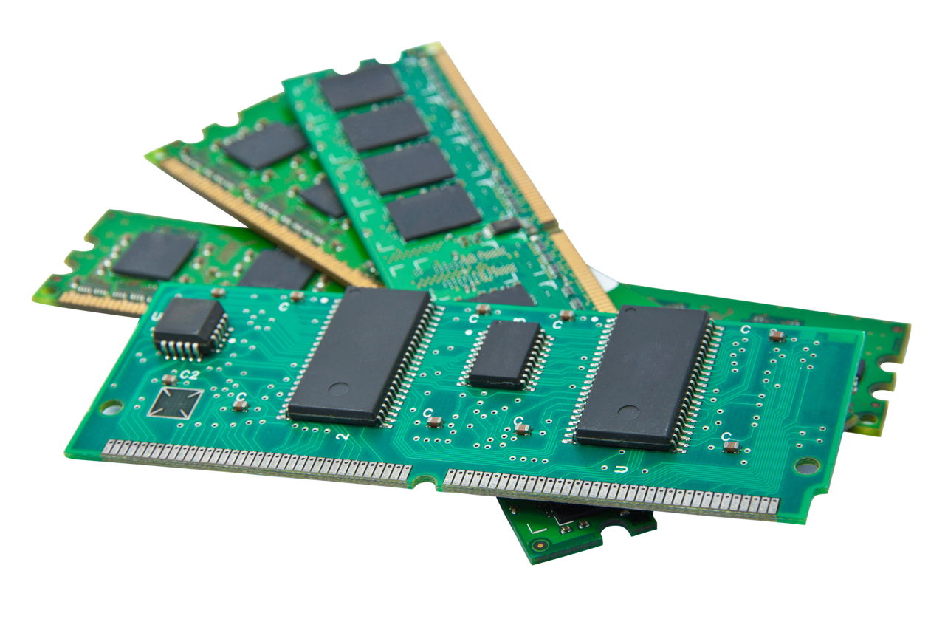

- A Visual Representation of a computer Primary Memory

LOGICAL MEMORY CONFIGURATION

- The proposed configuration memory works by reading on-chip configuration data into a buffer, modifying them based on the externally supplied data and writing them back to their original registers
- Logical memory is the address space, assigned to a logical partition, that the operating system perceives as its main storage. For a logical partition that uses shared memory (hereafter referred to as a shared memory partition), a subset of the logical memory is backed up by physical main storage and the remaining logical memory is kept in auxiliary storage.
You can configure minimum, maximum, desired, and assigned logical memory sizes for a shared memory partition.
- Minimum - The minimum amount of logical memory with which you want the shared memory partition to operate. You can dynamically remove logical memory from the shared memory partition down to this value.
- Maximum - The maximum amount of logical memory that the shared memory partition is allowed to use. You can dynamically add logical memory to the shared memory partition up to this value.
- Desired - The amount of logical memory with which you want the shared memory partition to activate.
- Assigned - The amount of logical memory that the shared memory partition can use. A shared memory partition does not have to use all of its assigned logical memory at any given time.

On systems that are managed by a Hardware Management Console (HMC), you configure the minimum, maximum, and desired logical memory sizes in the partition profile. When you activate the shared memory partition, the HMC assigns the desired logical memory to the shared memory partition.

RAM

- Random access memory (RAM) is a computer's short-term memory, which it uses to handle all active tasks and apps.Computers are always loading things in to work on — such as applications and data — and then setting them aside for later.
- RAM is your computer’s short-term memory. In contrast, a computer’s hard disk or SDD is its long-term memory, where things are stored more or less permanently.

DRAM

- Dynamic random access memory (DRAM) is a type of semiconductor memory that is typically used for the data or program code needed by a computer processor to function.
- DRAM is a common type of random access memory (RAM) that is used in personal computers (PCs), workstations and servers. Random access allows the PC processor to access any part of the memory directly rather than having to proceed sequentially from a starting place.
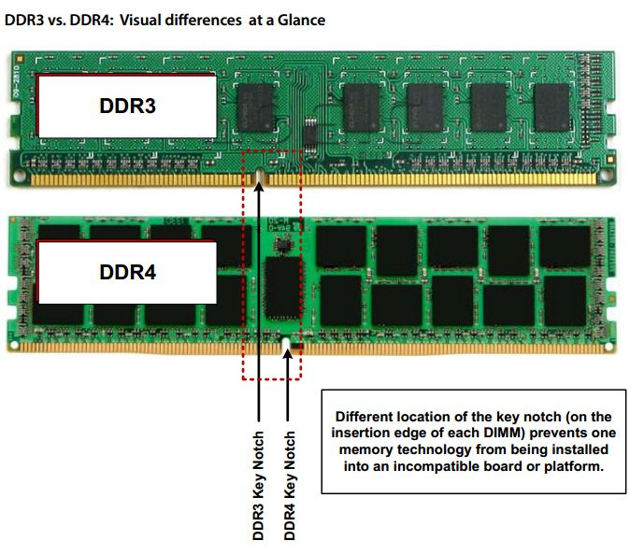
- Memory is made of bits of data or program code that are arranged in a two-dimensional grid. DRAM will store bits of data in what's called a storage, or memory cell, consisting of a capacitor and a transistor.
- The storage cells are typically organized in a rectangular configuration. When a charge is sent through a column, the transistor at the column is activated. A DRAM storage cell is dynamic, meaning that it needs to be refreshed or given a new electronic charge every few milliseconds to compensate for charge leaks from the capacitor.
- The memory cells will work with other circuits that can be used to identify rows and columns, track the refresh process, instruct a cell whether or not to accept a charge and read or restore data from a cell.
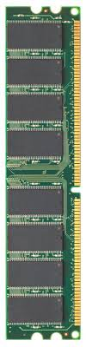
SRAM
- Static random-access memory (static RAM or SRAM) is a type of random access memory (RAM) that uses latching circuitry(flip-flop) to store each bit. SRAM is volatile memory; data is lost when power is removed.

- The term static differentiates SRAM from DRAM (dynamic random-access memory) which must be periodically refreshed. SRAM is faster and more expensive than DRAM; it is typically used for the cache and internal registers of a CPU while DRAM is used for a computer's main memory.

MEMORY ERRORS
- A memory read error is a malfunction that occurs when data is being accessed from memory for use by a program, or when a value read from RAM fails to match an expected value. Memory read errors can cause miscalculations, program malfunctions, unresponsiveness, the blue screen of death (BSOD) and spontaneous restarts.
- There are two types of soft memory errors:
- Chip-Level Soft Errors are usually due to the radioactive decay of elements in the memory chip packaging.
- System-Level Soft Errors usually occur when the data being processed is hit with a glitch or noise while data is on the data bus.
CMOS
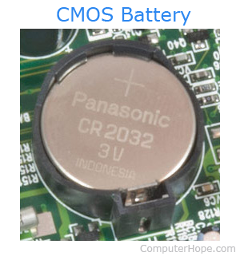
- Alternatively referred to as a RTC (real-time clock), NVRAM (non-volatile RAM) or CMOS RAM, CMOS is short for complementary metal-oxide semiconductor.
- CMOS is an onboard, battery powered semiconductor chip inside computers that stores information.

